**gPRC Tutorial**

Read: <https://grpc.io/docs/guides/>

Read: <https://grpc.io/docs/guides/concepts/>

Note the examples use gradle – an open source build-automation system like Maven and Ant.

<https://docs.gradle.org/current/userguide/what_is_gradle.html>

If all you want to do is run an existing Gradle build, then you don’t need to install Gradle if the build has a Gradle Wrapper, identifiable via the gradlew and/or gradlew.bat files in the root of the build – which you have here. You just need to make sure your system satisfies Gradle’s prerequisites (java version 8 or higher)

1. Follow the Java QuickStart at <https://grpc.io/docs/quickstart/java.html>

Run the Hello World example

The service (defined in helloworld.proto)

// The greeting service definition.

service Greeter {

// Sends a greeting

rpc SayHello (HelloRequest) returns (HelloReply) {}

rpc SayHelloAgain (HelloRequest) returns (HelloReply) {}

}

// The request message containing the user's name.

message HelloRequest {

string name = 1;

}

// The response message containing the greetings

message HelloReply {

string message = 1;

}

cd to grpc-java\examples folder

gradlew installDist

Run Server: build\install\examples\bin\hello-world-server.bat

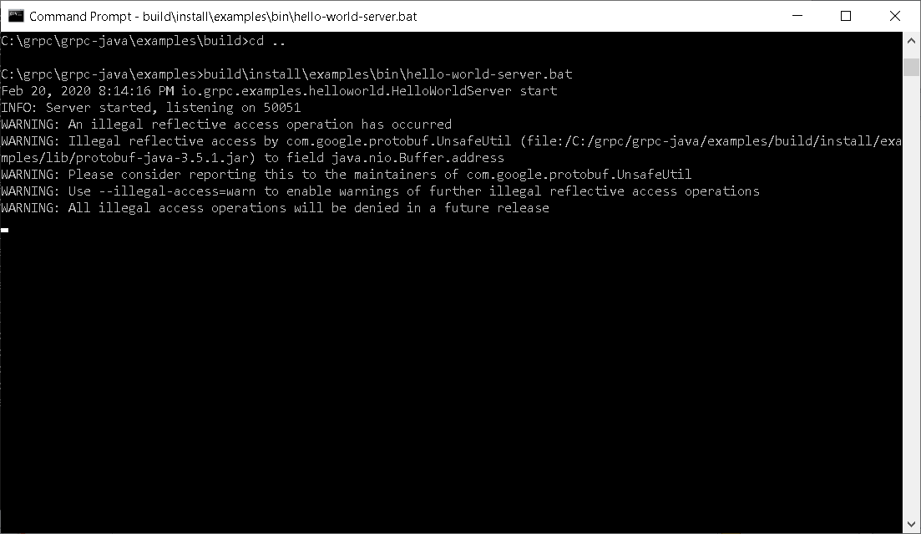

In another command window

Run Client build\install\examples\bin\hello-world-client.bat

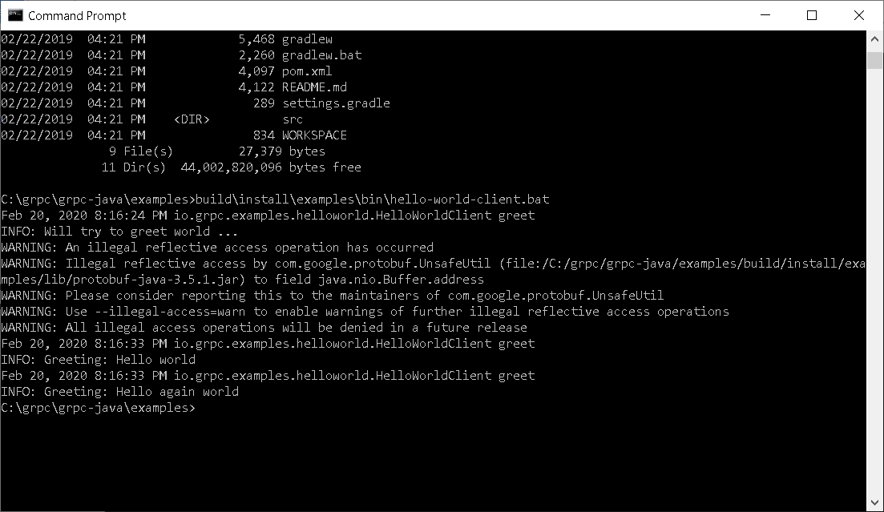

Now look at the code for the client and server and the proto files

1. Try the Route Guide

View the proto file for the route guide example

To run server from examples

build\install\examples\bin\route-guide-server

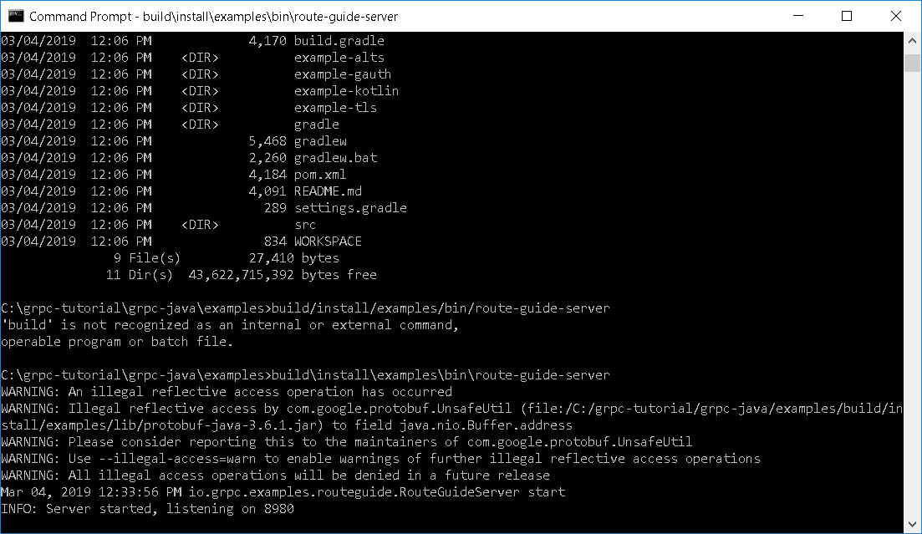

To run client from examples

build\install\examples\bin\route-guide-client

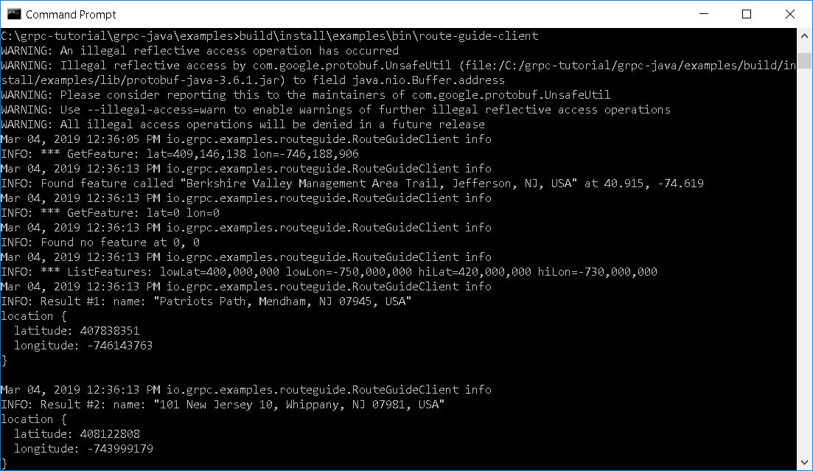

1. If you wish you can work through the Java Basics Tutorial in your own time at <https://grpc.io/docs/tutorials/basic/java.html>